**Sequence Diagram: Home Page**

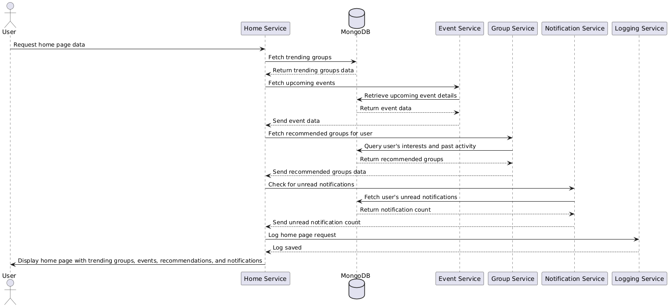

**Database**

**Functional Requirements (FRs)**

* **FR1:** The system shall display trending groups, recommended groups, and upcoming events on the homepage.
* **FR2:** The system shall fetch and display unread notifications for the user.
* **FR3**: The system shall provide a search bar for users to search for specific groups, events, or discussions.
* **FR4**: The system shall provide **quick links** to recently accessed groups and events on the homepage.

**Non-Functional Requirements (NFRs)**

* **NFR1:** The homepage should load in under 2 seconds.
* **NFR2:** The system should implement caching to reduce database load.
* **NFR3:** The homepage should support real-time updates for notifications.
* **NFR4:** The system shall support responsive design, so the homepage is optimized for various devices (desktop, tablet, mobile).